PB&J sandwich receipt

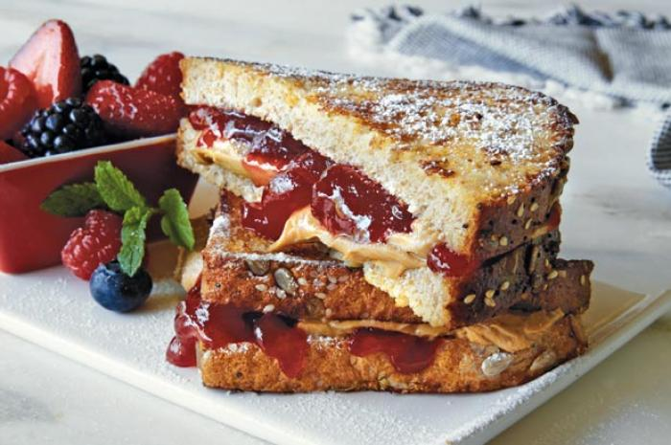

Our aim today is to make a delicious PB&J (Peanut Butter & Jelly/Jam) sandwich!

First of all, we need to gather all the ingredients and equipment:

For the ingredients, we need:

1. Two slices of bread. Choose whichever you like. No matter they are square pieces or rectangle ones. Just make sure their shapes enable them to be combined in the end.
2. Peanut butter of your choice
3. Jam, jelly or preserves of your choice

For the equipment, we need:

1. A clean, flat surface which allows you to put your bread on it. E.g. a clean chopping board.
2. A clean butter knife

So, after all things are done, it is like this.

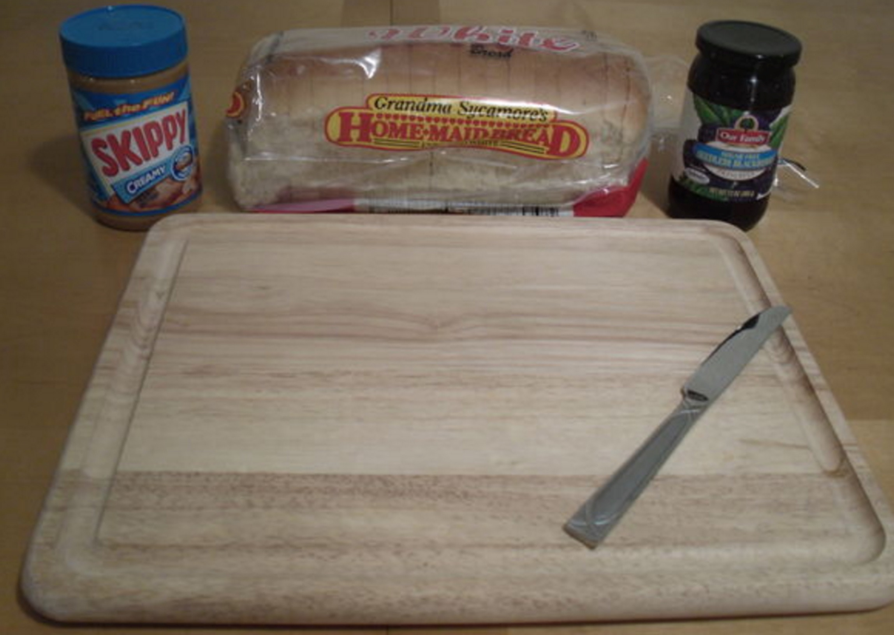

Now, we are heading to make the sandwich!

Procedure:

1. Put your two slices of bread on your flat surface.

Note: They should not be overlapped with each other. You can place them like this:

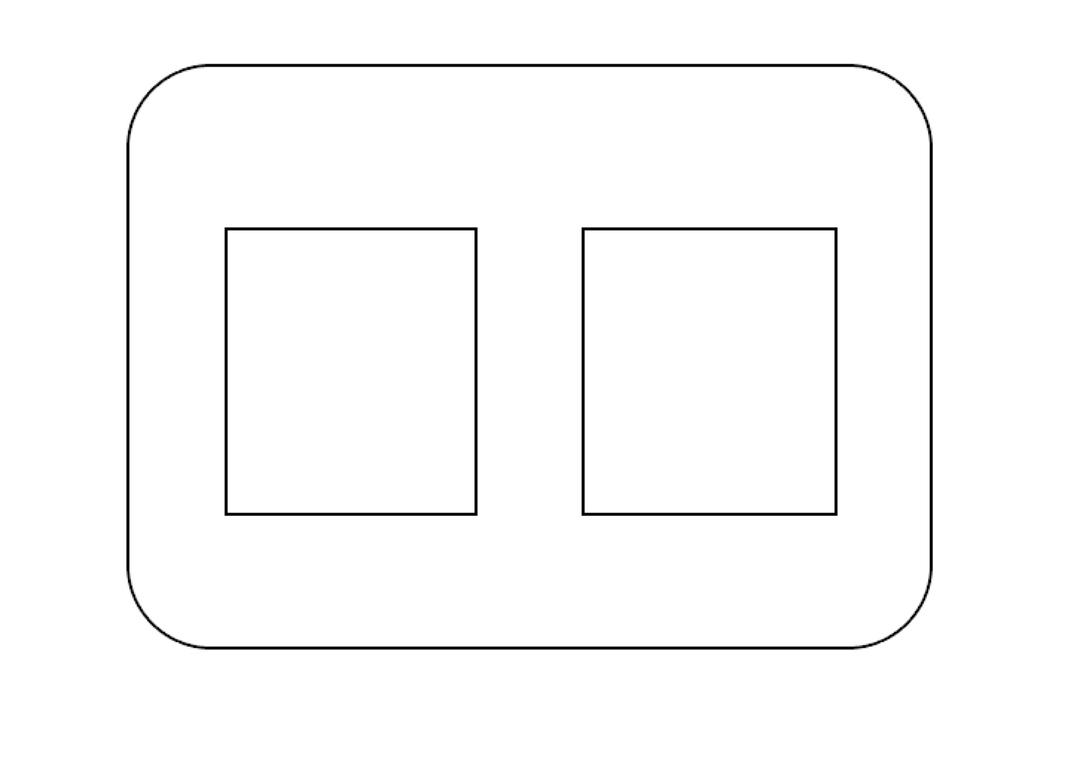

1. Apply Peanut Butter
2. Choose one bread that you want to apply peanut butter, keep in mind.
3. Grab your peanut butter jar and open the jar hat. You can put your right hand on the hat (you can definitely use your left hand if you want), and then grip the jar hat, scroll it clockwise. Keep doing it until the hat can be taken out of the jar.
4. Using you knife, scoop a large dollop of peanut butter.
5. Pick up the bread you have chosen before.
6. Spread peanut butter onto the top of the bread you have picked up. When applying your peanut butter, you should try to put it evenly on the surface of the bread. Dot your peanut butter on the bread will be a good choice.

You can apply your peanut butter like this:

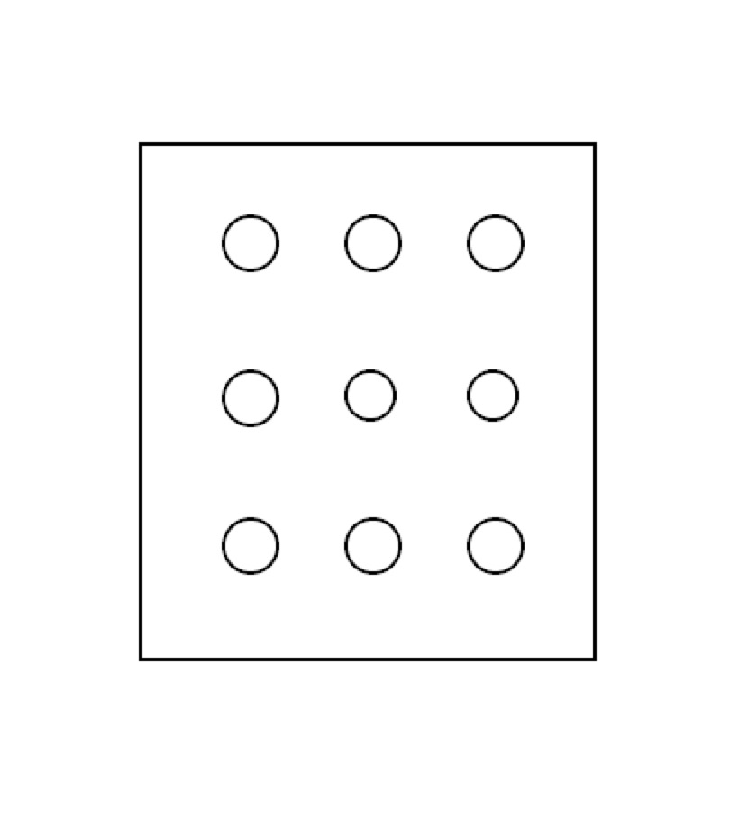

1. Then use your knife to spread those dots everywhere on your bread.
2. Apply jam/jelly/other preserves

Note: using the same technique as with the peanut butter.

1. Clean your knife.
2. pick up the other bread.
3. Grab your jam/jelly/other preserves jar. Open it following the same procedure you used to open peanut butter jar.
4. Use your knife to scoop out the desired amount of jam/jelly/other preserves and apply to your bread.
5. Spread jam/jelly/other preserves evenly on your bread.
6. Combine two slices of bread
7. have one piece of bread on the clean surface.
8. Carefully put the other piece of bread on the top of the one on the surface.

Note: it doesn’t matter if we apply peanut butter bread on the jam/jelly/other preserves one and vice versa.

1. Everything finished! Let’s eat our delicious PB&J sandwich!

Words count: 440